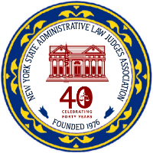
NEW YORK STATE ADMINISTRATIVE LAW JUDGES ASSOCIATION
518-285-0070 • www.nysalja.org
2016-2017 EXECUTIVE COMMITTEE

HON. EDWARD R. MEVEC
President

HON. RAYMOND KRAMER
President Elect

HON. JAMES T. McCLYMONDS
Vice-President

HON. ANNE W. MURPHY
Treasurer

HON. EMILY GEORGIADES
Secretary

HON. ERIC ZAIDINS
Immediate Past President

HON. SALLIE A FARROW
Executive Committee Member

HON. MELISSA DAVIS
Executive Committee Member

HON. DANIEL SCOTT
Executive Committee Member

HON. VILDA MAYUGA
Executive Committee Member

HON. CECILIA ANEKWE
Executive Committee Member

PAST PRESIDENTS
Hon. Ruth B. Kraft
Hon. James T. McClymonds
Hon. Marc P. Zylberberg
Hon. John G. Farrell
Hon. Anne W. Murphy
Hon. Michael Danziger
Hon. Catherine Bennett
Hon. Marc P. Zylberberg
Hon. James F. Horan
Hon. Peter S. Loomis
Hon. Tyrone T. Butler
Hon. Abigail S. Bernhardt
Hon. Theodore Vassilakis
Hon. James E. Brown
Hon. Margaret Giovanniello

October 23, 2016

