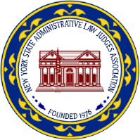
NEW YORK STATE ADMINISTRATIVE LAW JUDGES ASSOCIATION
518-285-0070 • www.nysalja.org
2014-2015 EXECUTIVE COMMITTEE

HON. ERIC ZAIDINS
President

HON. EDWARD R. MEVEC
President Elect

HON. GAYLE EVERITT
Vice-President

HON. ANNE W. MURPHY
Treasurer

HON. CHRISTOPHER STEPHENS
Secretary

HON. SALLIE A FARROW
Executive Committee Member

HON. RAYMOND KRAMER
Executive Committee Member

HON. ROBIN STROUP
Executive Committee Member

HON. REBECCA SCHWARTZ
Executive Committee Member

HON. DANIEL SCOTT
Executive Committee Member

PAST PRESIDENTS
Hon. Ruth B. Kraft
Hon. James T. McClymonds
Hon. Marc P. Zylberberg
Hon. John G. Farrell
Hon. Anne W. Murphy
Hon. Michael Danziger
Hon. Catherine Bennett
Hon. Marc P. Zylberberg
Hon. James F. Horan
Hon. Peter S. Loomis
Hon. Tyrone T. Butler
Hon. Abigail S. Bernhardt
Hon. Theodore Vassilakis
Hon. James E. Brown
Hon. Margaret Giovanniello

October 23, 2014

